Display images using flask web framework

Sample code: <https://github.com/chualc/flaskDisplayImage>

Method 1: Hard-code image filename in html

**home.html**

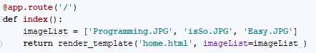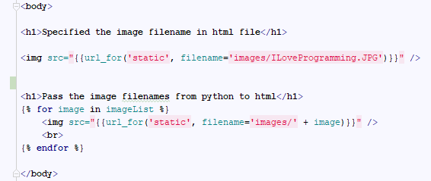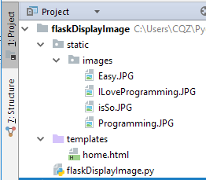

Method 2: Pass 3 image filenames to html.

**flaskDisplayImage.py**

**In the static folder, you can create an images folder to storing all the images.**